FIS Project1

ruei-Bo Chen

416082

2021

**1. Full GMRES**

For the full GMRES without preconditioning (set m = 600 to make it converge before restart), the relative error will converge below the threshold 10-8 after the 512th iteration. I would display relative residual ($\left\|\frac{r_{k}}{r_{0}}\right\|$), actual residual ($\left\|x_{k}-x^{*}\right\|$) and orthogonality here.

**(1) Unpreconditioned Full GMRES**

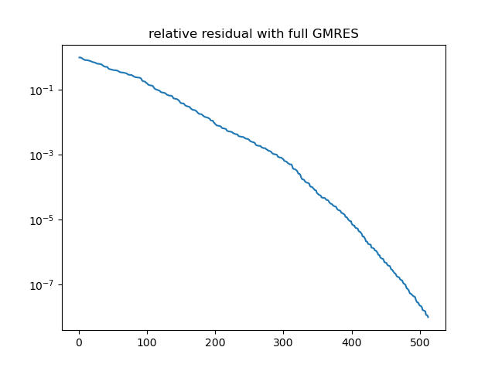

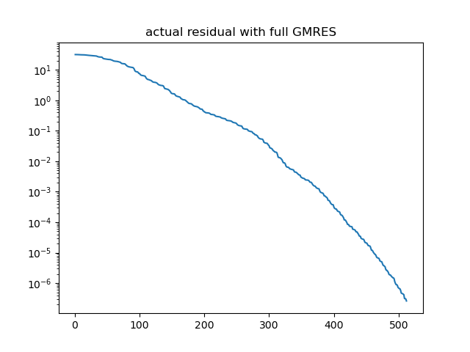

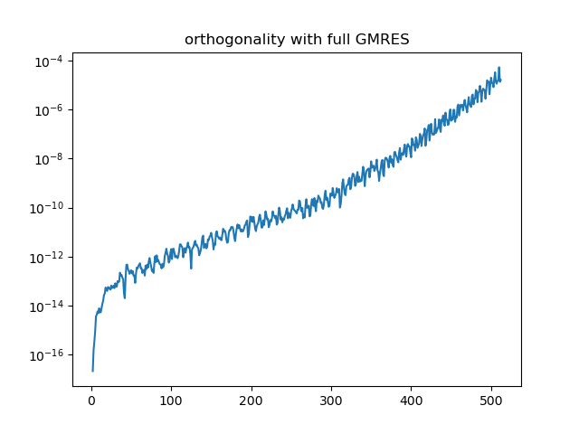

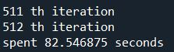

So we know that full GMRES without preconditioning takes 512 vectors to solve the system.

Next, apply Jacobi respectively to see the difference.

**(2) Full GMRES with Jacobi as preconditioner**

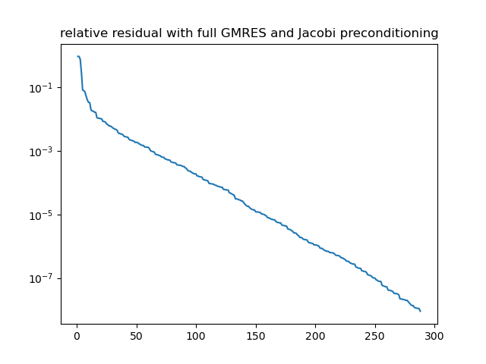

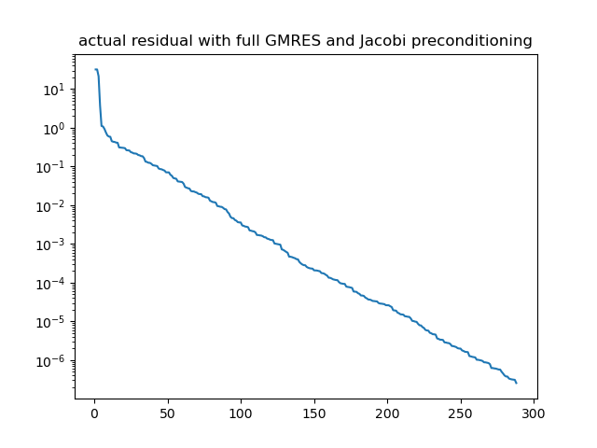

.

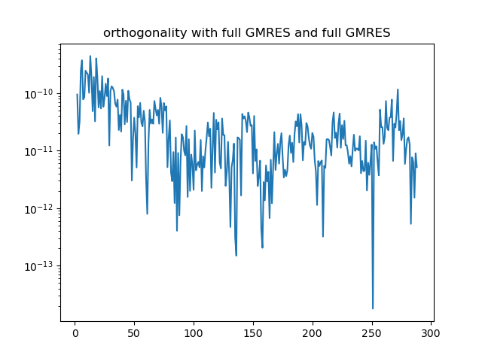

D:\Homework\RWTH\2nd_Semester\FIS\FIS_proj\Project1\plot\Jacobi_full.JPG

With Jacobi as preconditioner, we need just 288 vectors tot finish the calculation. The number of needed vectors decreased enormously.

Finally, the GMRES was done with Gauss-Seidel as preconditioner.

**(3) Full GMRES with Gauss-Seidel as preconditioner**

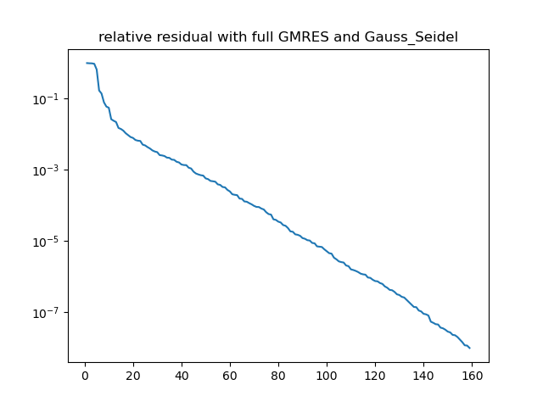

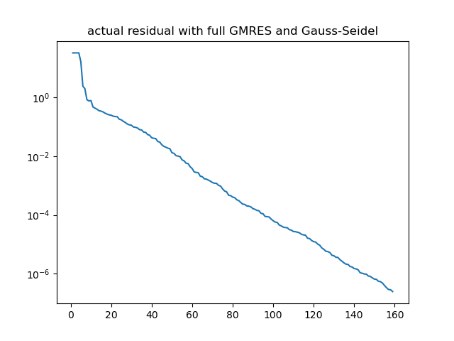

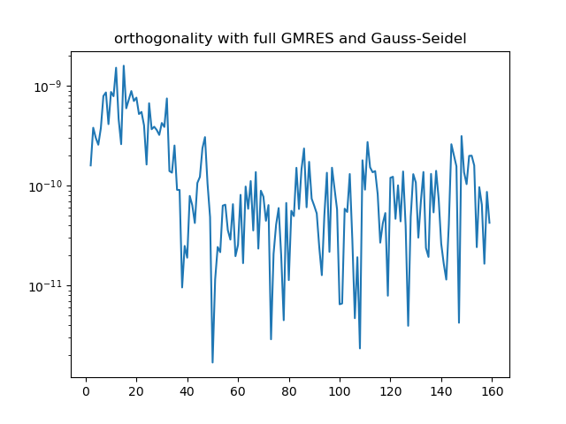

D:\Homework\RWTH\2nd_Semester\FIS\FIS_proj\Project1\plot\GS_full.JPG

It took only 159 vectors to solve the same system. Moreover, the spent time is just 1/10 of it without preconditioner.

**2. Restarted GMRES**

|  |  |
| --- | --- |
| Restarted GMRES with m = 10 | Can’t converge under the threshold |
| Restarted GMRES with m = 12 | 181.5s |
| Restarted GMRES with m = 30 | 53.3s |
| Restarted GMRES with m = 50 | 42.9s |
| Restarted GMRES with m = 100 | 48.9s |
| Full GMRES (equal to m = 600) | 84.5s |

From the table above, we notice that Restarted GMRES with any parameter m except for m = 10 are faster than Full GMRES. Restarted GMRES with m = 10 can’t converge to a number below the threshold.

I think the reason is that I build the matrix multiply function on my own, which takes many for loop to reach the result. It will consume a huge amount of time to finish the computation, especially when the size of matrix is large. Full GMRES requires multiplying matrix of size bigger than 100. As a result, Full GMRES will take much more time than Restarted GMRES.

In a better case, in which the memory are allocated well, Full GMRES might be faster than restarted GMRES. However, Full GMRES demand a large memory space to store all of the Krylov vectors needed, while restarted GMRES will fresh the vectors after m iteration. Thus, although Full GMRES probably take less time, it requires higher space complexity. We prefer to select Restarted GMRES if the available memory space is not enough.

Since m = 50 is likely to be the best parameter, I also apply those 2 preconditioner with this max iteration number.

**(1) Unpreconditioned with m = 50**

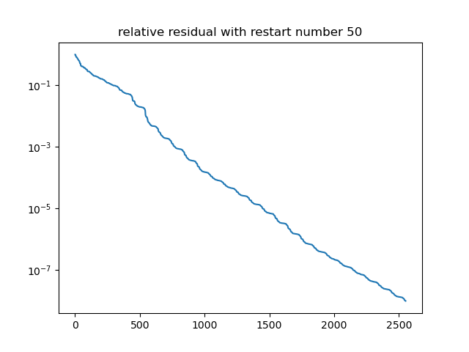

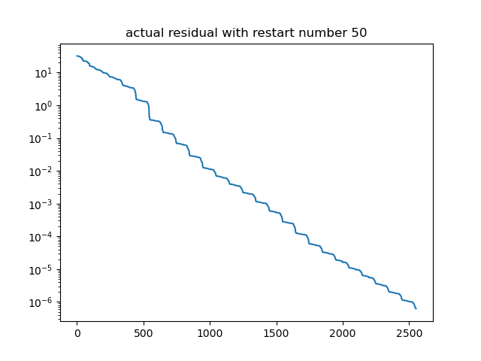

D:\Homework\RWTH\2nd_Semester\FIS\FIS_proj\Project1\plot\unpre_m50.JPG

**(2) Jacobi as preconditioner with m = 50**

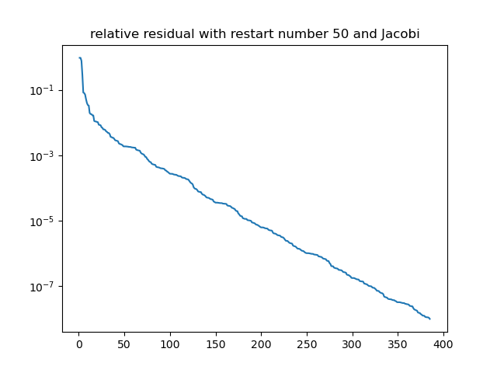

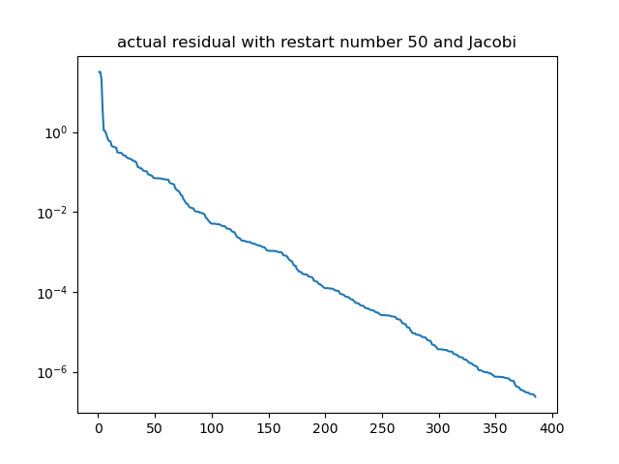

D:\Homework\RWTH\2nd_Semester\FIS\FIS_proj\Project1\plot\Jacobi_m50.JPG

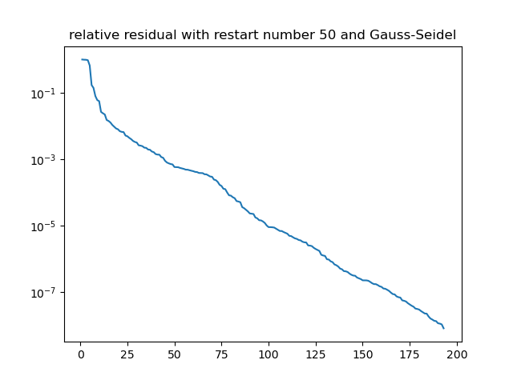**(****3)** **Gauss-Seidel as preconditioner with m = 50**

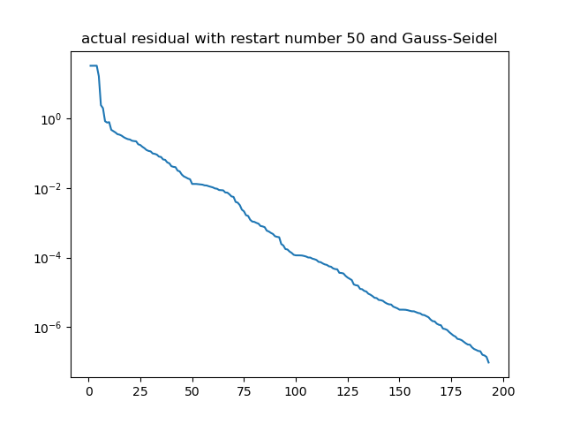

D:\Homework\RWTH\2nd_Semester\FIS\FIS_proj\Project1\plot\GS_m50.JPG

**3. CG Algorithm**

Not implemented